8-CMM

What is a Maturity Model?
A maturity model is like a progress ladder that shows how well an organization is doing something—for example, software development. It has levels that describe how organized and reliable the work is.
You can also use it to compare how different companies do similar work.

What is the Capability Maturity Model (CMM)?
The Capability Maturity Model (CMM) is a framework that helps organizations improve their software development processes. It has five levels of maturity, from very basic to highly advanced and efficient.

Structure of the CMM:
- Maturity Levels:
There are 5 levels. Level 1 is the most basic (chaotic), and Level 5 is the most advanced (optimized and improving).
- Key Process Areas (KPAs):
These are groups of important activities that help achieve goals at each level.
- Goals:
Each Key Process Area has goals. If those goals are met, it means the company is doing that part well.
- Common Features:
common features include practices that implement and institutionalize a key process area. There are five types of common features: commitment to perform, ability to perform, activities performed, measurement and analysis, and verifying implementation.
- Key Practices:
These are the important steps or actions that help a company do the work in a good, consistent way.

The 5 Maturity Levels (with simple examples):
- Level 1 – Initial (chaotic)
  - Work is not planned or documented. Everyone does things their own way.
  - uncontrolled and reactive manner by users or events. This provides a chaotic or unstable environment for the processes.
  - Example: A doctor trying a new surgery without much experience—results may vary a lot.
- Level 2 – Repeatable
  - some processes are repeatable. There's some consistency, but not very strong discipline.
  - Example: The doctor uses the same method again, but not very strictly.
- Level 3 – Defined
  - At this level, processes are clearly defined, documented, and improved over time. These standard processes exist but may not have been used enough for users to become fully skilled or for the process to be tested in different situations.
- Level 4 – Managed (Capable)
  - At this level, the process is well-controlled and consistently meets its goals in different situations. metrics are used to prove its effectiveness. The process has been tested and improved in various environments, and users are skilled in applying it under different conditions.
  - Example: The doctor has done the surgery many times, with very few mistakes.
- Level 5 – Optimizing (Efficient)
  - Focus is on constantly improving processes performance through new ideas and technology.
  - Example: The doctor not only performs the surgery well but also looks for better ways to do it.

9-Quality Management System QMS
Quality Management System QMS
Describe a process which ensures and demonstrates the quality of the products and services provided by an organization.
Set of Procedures/Processes which form basis for executing organization's product/service delivery mechanisms.
Properties
1. ISO 9001:2000 specifies requirements for QMS
It needs to consistently deliver products that meet customer and regulatory requirements. Aims to enhance customer satisfaction through the effective application of the system
2. A quality management system (QMS) ensures quality processes are effective and efficient by constantly reviewing and making controlled changes to its practices and tools. This keeps the QMS effective in a changing business environment.
3. Quality professionals are responsible for ensuring that training is provided within their areas. Employees must Have the necessary skills and Understand their responsibilities
4 . A successful QMS prioritizes early corrective action. Quality Control activities to be built at every stage to detect errors as early as possible before moving to next stage
Find root cause of an error and make action plan to prevent it.
5. A Quality Management System (QMS) for software development needs to ensure good quality products and services for both customers and developers. It must be auditable. The development process needs clear documentation, and quality records.
6. Quality records are documents within a QMS that show that quality goals are met and the QMS is working effectively.
7. Under ISO 9001:2000, an organization must:
- Establish, document, implement, and maintain a Quality Management System (QMS).
- Continually improve its QMS effectiveness.
8. ISO requires organizations to:
- Identify all necessary QMS processes and their applications throughout the organization.
- Define their order and how they interact.
- Set criteria and methods to ensure these processes are effective.
- Provide the resources and information needed to run and monitor them.
- Monitor, measure, and analyze these processes.
- Take actions to achieve planned results and continuously improve them.

10-SQE Inspection and FTR
Software inspection
Software inspection is a process in which other developers or team members review the code written by a developer to identify potential errors or areas for improvement.
The process should have entry criteria that determine if the inspection process is ready to begin. This prevent unfinished work products from entering the inspection process.
Fagan’s inspection
A Fagan inspection is a process of trying to find defects in documents during various phases of the software development process.
Inspection process stages
Planning: The inspection is planned by the moderator.
Overview meeting: The author describes the background of the work product.
Preparation: Each inspector examines the work product to identify possible defects.
Inspection meeting: During this meeting the reader reads through the work product, part by part and the inspectors point out the defects for every part.
Rework: The author makes changes to the work product according to the action plans from the inspection meeting.
Follow-up: The changes by the author are checked to make sure everything is correct.

Inspection roles
Author: The person who created the work product being inspected.
Moderator: This is the leader of the inspection. The moderator plans the inspection and coordinates it.
Reader: The person reading through the documents, one item at a time. The other inspectors then point out defects.
Recorder/Scribe: The person that documents the defects that are found during the inspection.
Inspector: The person that examines the work product to identify possible defects.

Structured Walkthrough
A review where the author leads the team through the document to explain and gather feedback.
Phases of Structured Walkthrough
Overview: In the overview phase the producer supplies the artifact to the coordinator and he distributes it to all the reviewers. The coordinator also sets the date and plan for the meeting.
Preparation: Reviewers individually examine the artifact and clarify any initial confusion.
Walkthrough: The artifact is presented, and reviewers give feedback and ask questions for clarification. No corrections are made. meeting will be 30-60 minute. Then the coordinator prepares the summary report and the list of the comments which is distributed to all the participants.
Rework: In this phase the producer do the necessary changes based on the comments of the participants.
Follow-up: During the follow-up phase the coordinator verifies the changes made to the artifact.
Team Roles of Structured Walkthrough
Coordinator: The coordinator does the planning and the organization of the walkthrough review process and he/she takes the role of the moderator during the walkthrough meeting
Producer: The producer is responsible to prepare the artifact that is to be reviewed
Reviewer: The reviewer's task is to find the defects from the artifact.

Two-person Inspection Process
This process was suggested by Bisant and Lyle in 1989. It is very useful for the evaluation of less experienced programmers' productivity. It includes all phase of Fagan's inspection process but the roles are reduced to two only i.e. author and a reviewer.
Phases
Same as Fagan's inspection
Roles:
Author and Reviewer
Inspections vs Reviews
Inspections
Formal
requires face to face meetings
Quality records available
For major release
Reviews
Informal
Can be face to face, email exchange
quality records optional
for small code changes

11-SQE ISO 9126
ISO 9126 Standard Quality Model
The ISO 9126 software quality model identifies 6 main quality characteristics, namely:
Functionality
Reliability
Usability
Efficiency
Maintainability
Portability
Functionality (Does it do what it's supposed to do?)
- Suitability: Does the software provide the right functions for the intended tasks? (e.g., A word processor has features for writing and editing text).
- Accurateness: Does the software produce correct or agreed-upon results? (e.g., A calculator provides precise answers to calculations).
- Interoperability: Can the software interact with other specified systems? (e.g., Your email client can send and receive emails from different providers).
- Compliance: Does the software follow relevant standards, conventions, and regulations? (e.g., Financial software adheres to accounting standards).
- Security: Does the software protect against unauthorized access to data or programs? (e.g., A banking app requires a password and offers encryption).
Reliability (Does it work consistently and recover from issues?)
- Maturity: How often does the software fail due to defects? (e.g., A mature system has very few crashes).
- Fault tolerance: ability of the software to maintain performance even when there are faults or issues? (e.g., If one part of a server crashes, the system still keeps running).
- Recoverability: How easily and quickly can the software restore its performance and data after a failure? (e.g., After a power outage, a system can quickly restart and recover unsaved work).
Usability (Is it easy to use?)
- Understandability: Is it easy for users to grasp the software's purpose and how to use it? (e.g., The menu names clearly indicate their functions).
- Learnability: How easy is it for users to learn to use the software? (e.g., A new user can quickly figure out how to send a message in a chat app).
- Operability: Is it easy to operate and control the software? (e.g., Common actions are easily accessible and require minimal steps).
Efficiency (Does it use resources well?)
- Time behavior: How quickly does the software respond and process tasks? (e.g., A website loads quickly, a game runs smoothly without lag).
- Resource behavior: How much memory, CPU, or network resources does the software use? (e.g., A program doesn't consume excessive battery life on a mobile device).
Maintainability (Is it easy to change and fix?)
- Analyzability: How easy is it to diagnose problems or identify parts to be modified? (e.g., The code is well-structured and commented, making it easy to understand).
- Changeability: How easy is it to modify the software, remove faults, or adapt it to environmental changes? (e.g., Adding a new feature doesn't break existing ones).
- Stability: the ability of the software to continue to function over time without failure (e.g., Small changes don't cause widespread bugs).
- Testability: How easy is it to test the modified software to ensure it still works correctly? (e.g., There are clear ways to verify that changes have been implemented correctly).
Portability (Can it be moved to different environments?)
- Adaptability: Can the software be easily adapted to different environments without major changes? (e.g., Software can run on different operating systems).
- Installability: How easy is it to install the software in a specific environment? (e.g., The installation process is straightforward and automated).
- Conformance: Does the software adhere to standards or conventions related to portability? (e.g., It uses common file formats that are widely supported).
- Replaceability: Can the software be used to replace other specified software in the same environment? (e.g., A new browser can seamlessly replace an old one).

12-GQM
The Goal-Question-Metric (GQM) approach is a way to define and achieve measurement goals. It works in three interconnected levels:

Conceptual Level (Goal)

A goal is defined for an object, for a variety of reasons, with respect to various models of quality, from various points of view and relative to a particular environment.

Operational Level (Question)
Once you have a goal, you ask specific set of questions that will help you understand if you're meeting your goal. These questions break down your big goal into smaller, clearer parts.

Quantitative Level (Metric)
A set of metrics, based on the models, is associated with every question in order to answer it in a measurable way.

14-Software Testing
Software testing is a formal process carried out by a specialized testing team in which a software unit, several integrated units or an entire software package are examine by running the program on a computer.
Direct objectives
a) To identify as many errors as possible in the tested software.
b) After fixing identified errors and retesting, the software should reach a satisfactory level of quality.
c) To perform the required tests efficiently and effectively, within the budgetary and scheduling limits.
Indirect objectives
a) keep the record of all errors found for use in error prevention

level of testing
Unit Testing: Testing individual, smallest parts (units) of the code in isolation. Think of testing a single function or method to ensure it works correctly by itself.
Integration Testing: Testing how different individual units or modules work together when combined. This checks the interfaces and interactions between them.
System Testing: Testing the complete and integrated software system as a whole. This verifies that the entire system meets its specified requirements and functions as intended in its environment.
Acceptance Testing: The final level of testing where the software is tested by the end-users or clients to confirm it meets their business requirements and is ready for delivery. It ensures the software is acceptable for release.
strategies for integration testing
Bottom-Up Testing
You start by testing the lowest-level modules (the smallest, most basic parts of the code) first. Once those are working well, you combine them into slightly larger groups and test those.
The process continue until all modules at top level are tested.
Top-down testing
you start by testing highest level modules first. And then the branches of the module are tested step by step until the end of the related module

Big-Bang Testing
Instead of integrating and testing incrementally, you combine everything at once and test the entire system as a single, large unit.
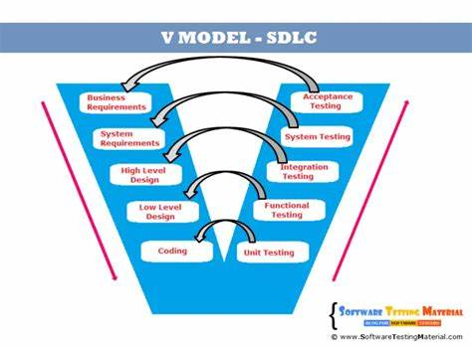

15-Test Maturity model
The Test Maturity Model (TMM) describes how advanced and organized an organization's software testing process is, moving from very basic to highly optimized.
Level 1: Initial
Goals: Software should run successfully
- At this level, no defined testing process
- An objective of testing is to ensure that software is working fine
- This level lacks resources, tools, and trained staff
- No Quality Assurance checks before software delivery.
Level 2: Defined
Goals: Develop testing and debugging goals and policies.
- Testing and debugging are considered distinct activities
- Testing phase comes after coding
- A primary goal of testing is to show software meets specification
- Basic testing methods and techniques are in place.
Level 3: Integrated
Goals: Integration of testing into the software lifecycle
- Testing gets integrated into an entire life cycle
- Test objectives are set based on the software's requirements
- Test organization exists
- Testing recognized as a professional activity.
Level 4: Management and Measurement
Goals: Establish a test measurement program
- Testing is a measured and quantified process
- Reviews during all development phases are considered as tests.
- Test cases are saved for reuse and regression testing
- defects are logged with severity levels.
Level 5: Optimized
Goals: Test process optimization
- the test process is continuously improved and optimized.
- The effectiveness and cost of testing are tracked
- strong focus on quality control and defect prevention.
- Tools are used to help with test case design and defect tracking

Black Box Testing
Black box testing is software testing technique where the tester focuses on the external behavior of the software, without having access to its internal source code.
Key Characteristics:
- External Perspective: Tests are designed from the end-user's point of view.
- No Code Knowledge Required: Testers don't need access to the source code or knowledge of internal algorithms.
- Focus on Functionality: Verifies what the software does rather than how it does it.
- Applicable at various levels: Can be applied at unit, integration, system, and acceptance testing levels.
Types of Black Box Testing:
- Functional Testing: It verifies that each function and feature of the software works according to its specifications.
Examples: Testing login functionality, form submissions, search functionality, etc.

- Non-Functional Testing: It includes tests for quality attributes like performance, usability, security, scalability, reliability etc.
Examples: Does the app load under 2 seconds even with slow internet connection ?

- Usability Testing: Assesses how easy and user-friendly the software is.
Example: either they struggle to find the payment option or find it confusing

- Performance Testing: Evaluates the software's speed, responsiveness, and stability under various loads (e.g., load testing, stress testing).

- Security Testing: Identifies vulnerabilities and weaknesses in the software's security from an external attacker's perspective (e.g., penetration testing without code access).

- Compatibility Testing: Checks if the software works correctly across different platforms, browsers, devices, etc.

- Regression Testing: Ensures that new code changes, bug fixes, or enhancements haven't negatively impacted existing functionality. It involves re-running previously passed test cases.
Examples: Suppose the music app adds a new “offline mode” feature. You’re-test old features to ensure they still work.

- User Interface Testing: It Tests the software’s graphical interface to ensure it’s visually correct, consistent, and easy to navigate.
Example: Consider a Food Delivery App(Food Panda) The order now button is visible and clickable ? The menu layout is the same on iPhone and Android (e.g., no buttons are cutoff).

- User Acceptance Testing (UAT): This is the final stage of testing, often performed by end-users or clients, to ensure the software meets their business requirements and is fit for purpose.
Techniques of Black Box Testing:
- Equivalence Partitioning: Divides the input data into logical partitions (classes) where all values within a partition are expected to behave similarly. A single test case from each partition is then selected.
Example: For an age input field that accepts values between 18 and 65, partitions could be: Less than 18 (invalid), 18-65 (valid), and Greater than 65 (invalid).

- Boundary Value Analysis (BVA): Focuses on testing the values at the boundaries of the input ranges, as well as just below and above these boundaries. It is often used in conjunction with equivalence partitioning.
Example: For the age input field (18-65), BVA would test values like 17, 18, 19, 64, 65, 66.

- Decision Table Testing (Cause-Effect Graphing): Used for complex systems where different combinations of inputs lead to different outputs. A decision table maps out all possible input combinations and their corresponding actions/outputs.

- State Transition Testing: Applicable for systems that change their behavior or state based on certain events or sequences of inputs. It uses state transition diagrams to identify and test all possible states and transitions.

- Use Case Testing: Derives test cases from use cases, which describe how users interact with the system to achieve specific goals. Each step and scenario within a use case becomes a potential test case.

- Error Guessing: Relies on the tester's experience, intuition, and knowledge of common software vulnerabilities to "guess" where defects might exist. This is less systematic but can be very effective in finding bugs.

- All-Pairs Testing (Pairwise Testing): A combinatorial testing technique that ensures all possible pairs of input parameter values are tested at least once. This helps reduce the number of test cases while maintaining good coverage.

white Box Testing
white box testing is software testing technique where the tester focuses on internal structure and workings of a software application, having access to its internal source code.
verify the correctness of the software at the code level.
Key Characteristics:
- Internal Perspective: Tests are designed based on the actual code structure.
- Code Knowledge Required: Testers must have programming skills and a deep understanding of the software's architecture and logic.
- Focus on Internal Workings: Verifies how the software does what it does.
- Early Bug Detection: Can identify issues early in the development cycle, reducing the cost of fixes.
- Ensures Code Quality: Helps find dead code, security vulnerabilities within the code, and optimize code.
Types Of White Box Testing
Unit Testing: Testing individual, smallest parts (units) of the code in isolation. Think of testing a single function or method to ensure it works correctly by itself.
Integration Testing: Testing how different individual units or modules work together when combined. This checks the interfaces and interactions between them
Regression Testing: Ensures that new code changes, bug fixes, or enhancements haven't negatively impacted existing functionality. It involves re-running previously passed test cases.

White Box Testing Techniques
1. Statement Coverage: Ensures that every executable statement in the code is executed at least once.
Example 1:
a = 5, b = 10
c = a + b
print(c)
One test case is enough to cover all statements

2. Branch Coverage (Decision Coverage): Ensures that every possible outcome of each conditional statement (e.g., if-else, switch, loops) is executed. This means testing both the "true" and "false" branches of each decision.
Example 1:
if age >= 18:
print("Adult")
else:
print("Minor")
Test Cases:
age = 20 (True branch)
age = 16 (False branch)

3. Path Coverage: Aims to execute every possible independent path through the code at least once.
Example:
Input A,B
C=A+B
If C>100:
Print(“it’s done”)
If A>50:
Print(“it’s pending”)

4. Loop Testing: Specifically focuses on testing loops (e.g., for, while, do-while) to ensure they execute correctly under various conditions (zero iterations, minimum iterations, maximum iterations, typical iterations, exceeding maximum iterations).
- Nested loops: we start from the innermost loop. Simple loop tests are conducted for the innermost loop and this is worked outwards till all the loops have been tested.
- Concatenated loops: Independent loops, one after another. Simple loop tests are applied for each.

Example 1: Simple Loop
n=5
for i in range(n):
print(i)
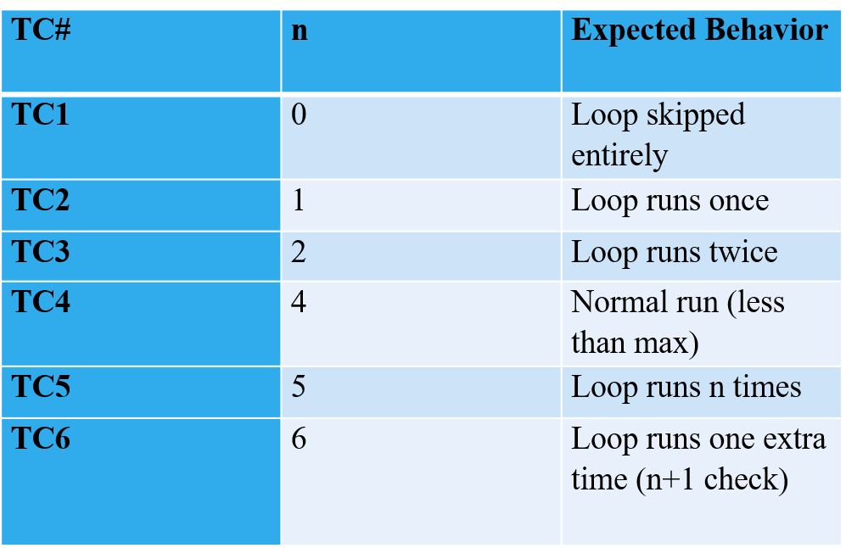

McCall’s classical model
• Product Operation Factors (How well the software runs): These factors focus on the basic operational characteristics of the software and how well it fulfills its specifications during daily use.
- Correctness: The extent to which the software meets its specified requirements and performs its intended functions accurately.
- Reliability: The degree to which the software performs its intended functions without failure under specified conditions over a given period.
- Efficiency: The amount of computing resources (e.g., CPU, memory, storage) and code required by the software to perform its functions.
- Integrity: The extent to which access to software or data by unauthorized persons can be controlled, addressing security aspects.
- Usability: The effort required for users to learn, operate, and understand the functions of the software.
• Product Revision Factors (How well the software can be changed): These factors relate to the ease with which the software can be modified, tested, and maintained in the future.
- Maintainability: The effort required to detect and correct errors, or to modify the software to improve performance or adapt to changes.
- Flexibility: The ease with which the software can be modified or adapted to accommodate changes in requirements, operating environment, or business needs.
- Testability: The effort required to test the software to ensure it performs its intended functions and meets specified requirements.
• Product Transition Factors (How well the software can be adapted to new environments): These factors address the software's ability to be transferred to different platforms, reused in other applications, or integrated with other systems.
- Portability: The effort required to transfer the software from one hardware or software environment to another.
- Reusability: The extent to which existing software components or modules can be reused in other applications, reducing development effort.
- Interoperability: The effort required to integrate the software with other systems or software products, enabling them to work together seamlessly.

software metric
A software metric is a simple way to measure and evaluate different aspects of software, such as its quality, performance, size, or progress.
Product Metrics
Describe the characteristics of product
- Size – line of code
- Measure code complexity – analyze how complicated the code is.
- Evaluate software quality – check for bugs, errors, and performance issues in the product.
- Maintainability – determine how easy it is to update, fix, or improve the software later.
- Functionality– ensure the software meets all required features and user needs.
- Reliability – properly working or not

Process Metrics
Evaluate the efficiency and effectiveness
- Development time
- Efficiency – check if the team is completing tasks on time and using resources wisely.
- Efficiency defect removal – number of defects caught before release
- Bug fix rate – measure how quickly bugs are resolved

Project Metrics
Track progress, cost and team performance
- Effort – effort in month per developer.
- project budget – ensure the project is staying within the planned cost.
- Measure team performance – evaluate how effectively the team is working.
- Schedule variance– compare planned progress vs actual progress

